Gradient Descent
Gradient Descent is the optimization algorithm used to minimize the loss.
Backpropagation is the method used to compute gradients.
Backprop calculates gradients
Gradient Descent uses them to update weights

Intuition: Imagine a Mountain
- The loss function forms a surface (like hills and valleys)
- We start at some random point (random weights)
- We want to reach the lowest valley (minimum loss)
Gradient Descent:
- Computes slope (gradient)
- Moves weights in the opposite direction of slope
- Repeats until loss is minimized

Mathematical View
Let:
- L = Loss
- w= weight
- 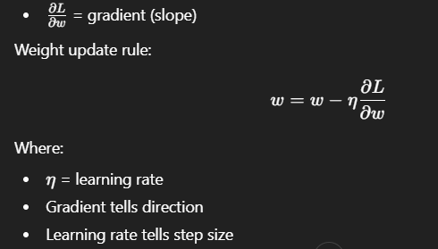

- Backprop calculates how much each weight contributed to the error, and gradient descent adjusts the weights slightly in the direction that reduces that error.

Types of Gradient Descent

Batch Gradient Descent
- Uses full dataset
- Stable but slow

Stochastic Gradient Descent (SGD)
- Uses 1 sample at a time
- Noisy but fast

Mini-batch Gradient Descent (Most Used)
- Uses small batches (32, 64, 128)
- Balanced approach
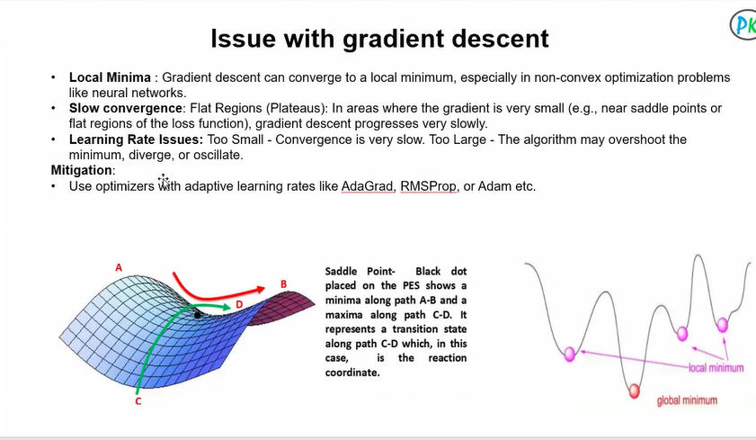
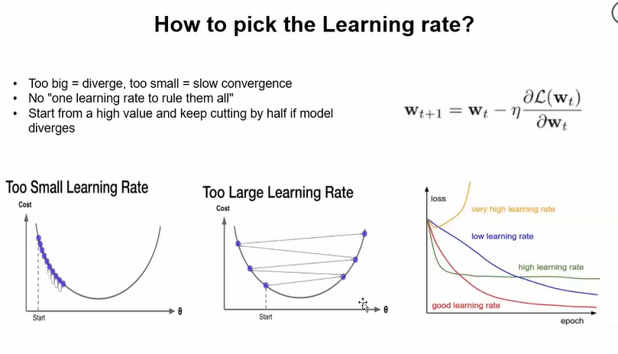
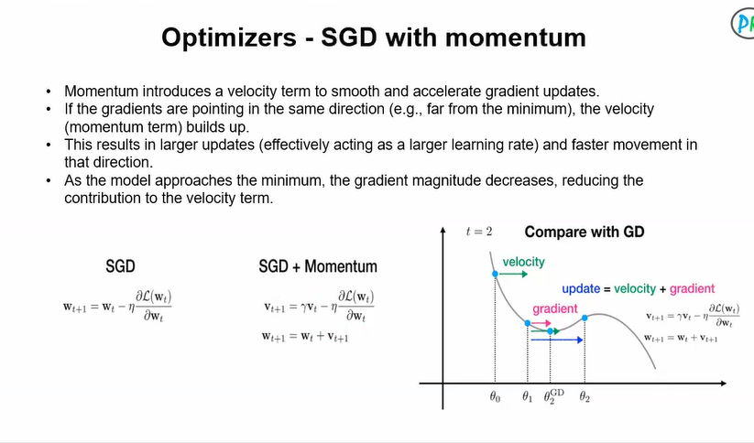
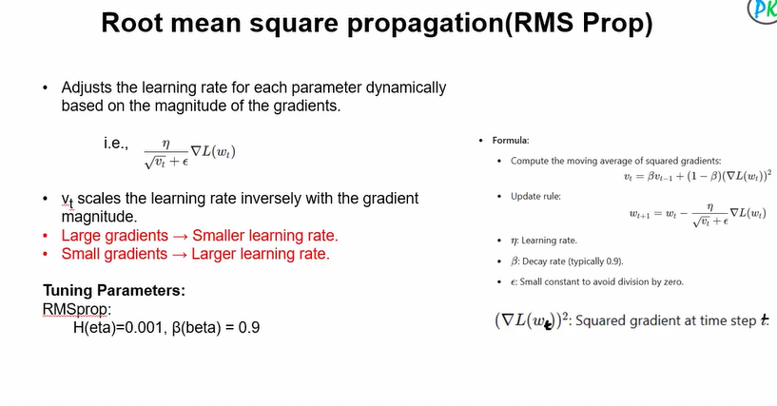
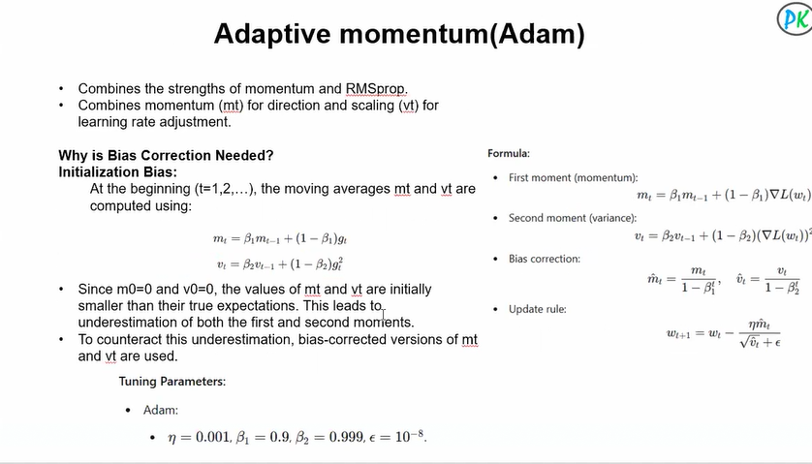
Gradient descent struggles with saddle points, vanishing/exploding gradients, poor learning rate selection, slow convergence, and unstable updates.
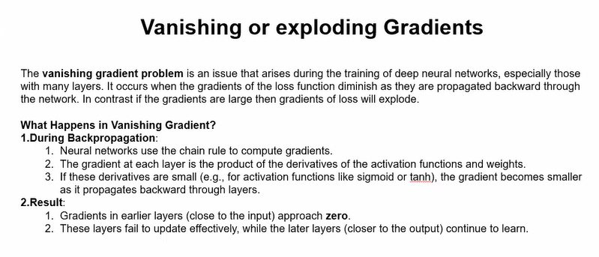
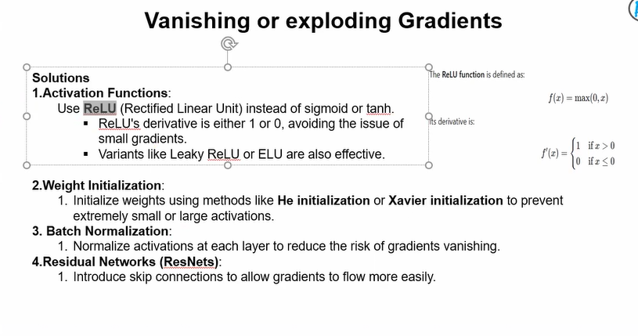

What is NLP?
NLP (Natural Language Processing) is a field of Artificial Intelligence that enables computers to understand, interpret, generate, and respond to human language.
It combines:
- Machine Learning
- Linguistics
- Deep Learning
- Statistics

Why Do We Need NLP?
Computers understand numbers, not language.
For example:
Humans understand:
"I love this movie"
Computer sees:
['I', 'love', 'this', 'movie']
NLP converts language into numerical form so machines can process it.

How NLP Works (Traditional Approach)
- Text Cleaning
- Tokenization
- Stopword Removal
- Stemming/Lemmatization
- Feature Extraction (TF-IDF, Bag of Words)
- Machine Learning Model

Modern NLP (Deep Learning Based)
Now we use:
- RNN
- LSTM
- Transformers
Most powerful architecture:
